**DAILY ONLINE ACTIVITIES SUMMARY**

|  |  |  |  |  |  |  |  |  |
| --- | --- | --- | --- | --- | --- | --- | --- | --- |
| **Date:** | **10/07/2020** | | | | | **Name:** | **NAIPUNYA VINOD NAIK** | |
| **Sem & Sec** | **IV SEM & A SECTION** | | | | | **USN:** | **4AL18CS050** | |
| **Online Test Summary** | | | | | | | | |
| **Subject** | | **OBJECTS ORIENTED CONCEPTS** | | | | | | |
| **Max. Marks** | | **30** | | **Score** | | | **----------** | |
| **Certification Course Summary** | | | | | | | | |
| **Course** | 1. **PYTHON PROGRAMMING WITH DATA SCIENCE** | | | | | | | |
| **Certificate Provider** | | | **UDEMY** | | **Duration** | | | **15 HRS** |
| **Coding Challenges** | | | | | | | | |
| **Problem Statement: -----------------------------** | | | | | | | | |
| **Status:-----------------------------------------------** | | | | | | | | |
| **Uploaded the report in Github** | | | | | **YES** | | | |
| **If yes Repository name** | | | | | <https://github.com/naipunya-naik/daily-progress-report> | | | |
| **Uploaded the report in slack** | | | | | **YES** | | | |

Online Test Details: (Attach the snapshot and briefly write the report for the same).

TODAY OBJECT ORIENTED CONCEPTS DESCRIPTIVE TEST-1 WAS CONDUCTED ON 10TH JULY 2020.

* SUBJECT:- OBJECT ORIENTED CONCEPTS
* CONDUCTED BY:- MS.SHILPA
* FROM 9.30 AM TO 10:15AM
* DURATION:- 45 MIN
* NO.OF QUESTIONS:-4
* TOTAL MARKS:- 30
* MARKS WILL BE PROVIDED SOON
* DUE TO SLOW INTERNET, MY DOCUMENT GOT UPLOADED AT 10.16AM , SO IT TURNED IN LATE.

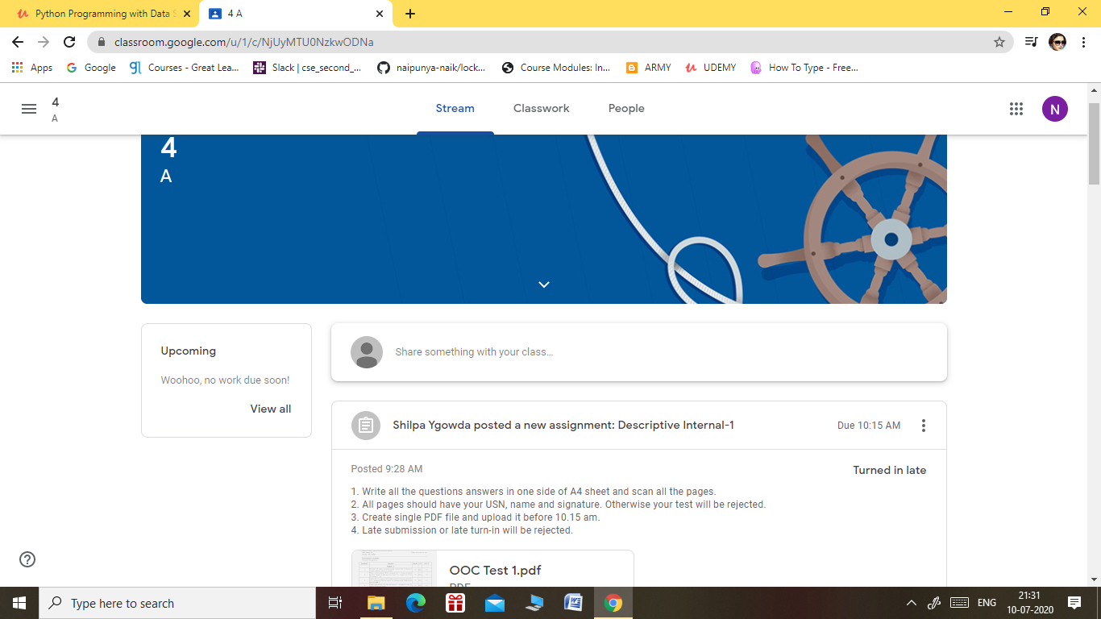

Certification Course Details: (Attach the snapshot and briefly write the report for the same).

CERTIFICATION COURSE NAME:- **PYTHON PROGRAMMING WITH DATA SCIENCE**

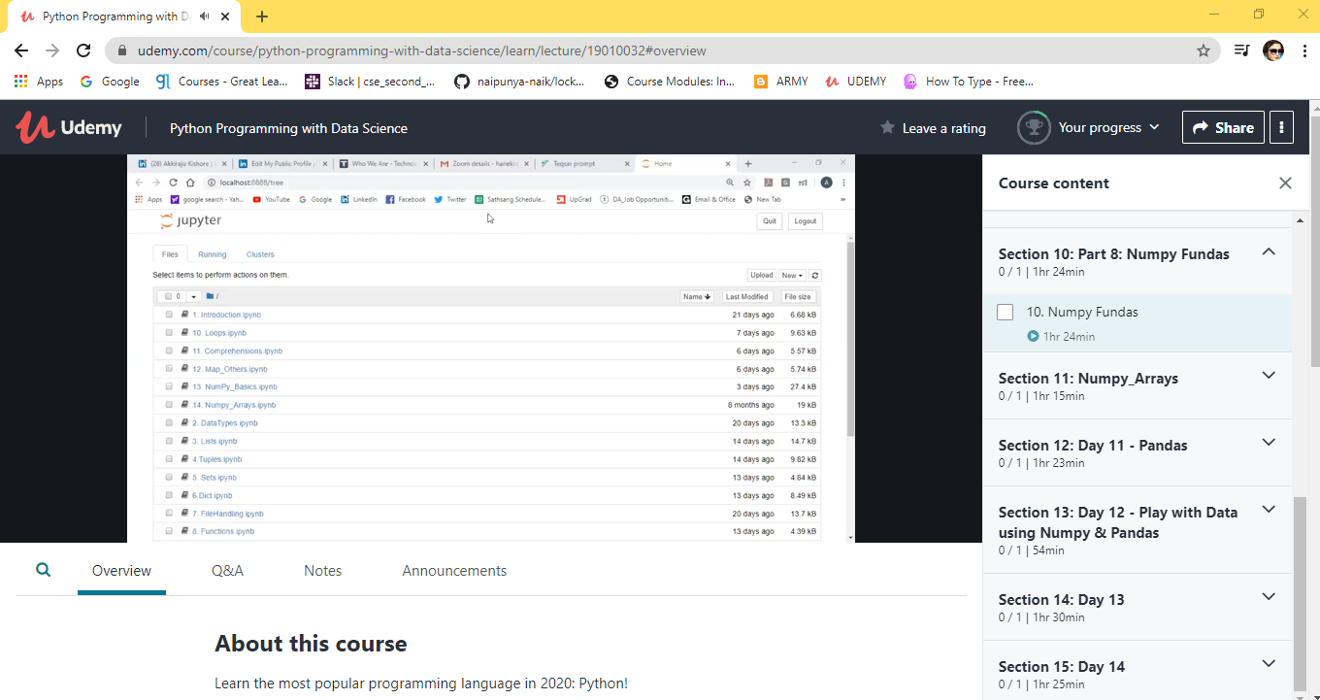

TOPICS COVERED TODAY ON 10 JULY 2020:-

**Section 8: Python: Part 6 Set  
function and Dictionaries**

**Section 9: Part 7: Conditional  
Statements: IF Elif Else**

**Section 10: Part 8: Numpy Funda**

**Section 11: Numpy_Arrays**

Coding Challenges Details: (Attach the snapshot and briefly write the report for the same).

NO PROBLEM STATEMENTS GIVEN TODAY.